*Note: pay attention to cursor measurement (bottom right corner).*

Using small wires and scope probe I was measuring signal before R27 resistor, you can see results in images below. Measuring was provided using AC mode of the oscilloscope. We can notice that this glitch is almost identical to the glitch from DAC datasheet:

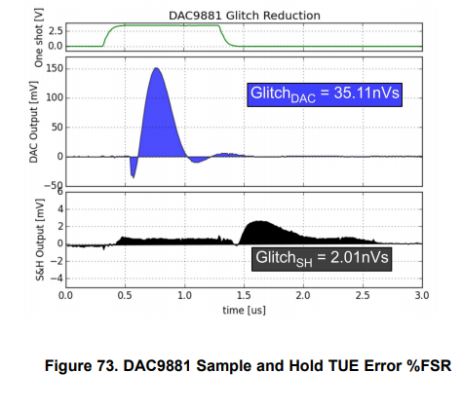

Figure 1: Glitch from DAC datasheet.

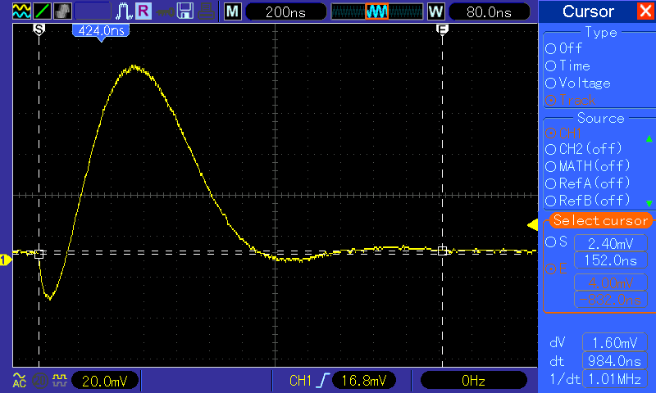

Figure 2: Length of glitch 984ns.

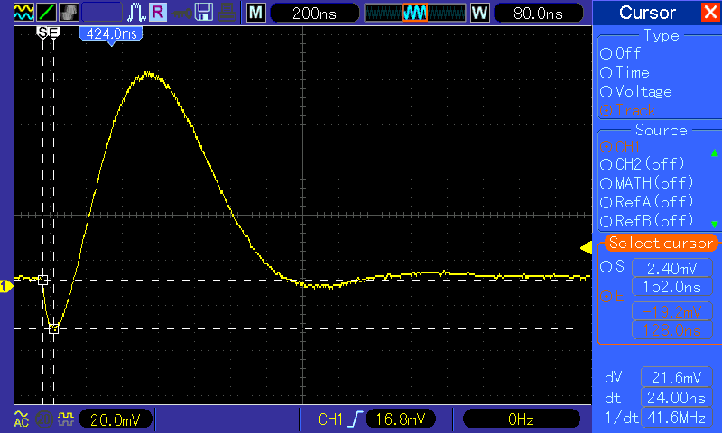

Figure 2: First undershoot, voltage peak 21.6mV.

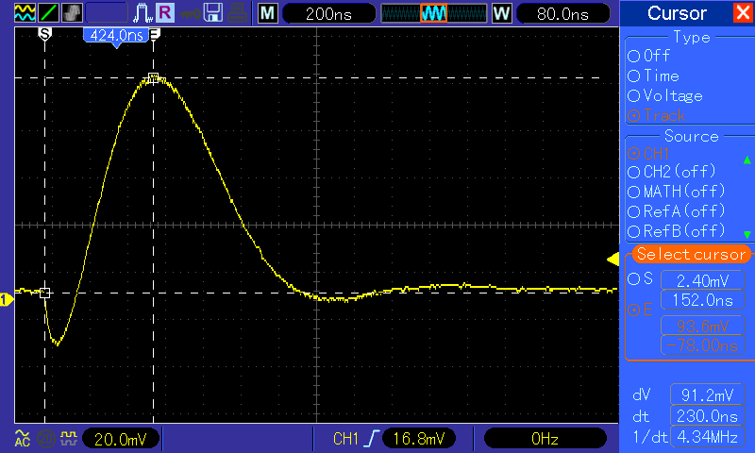

Figure 3: first overshoot, voltage peak 91.2mV.

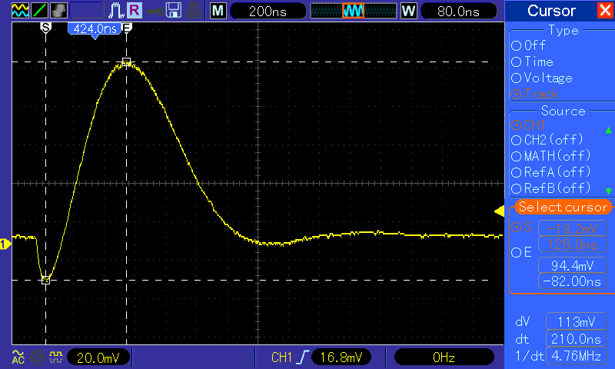

Figure 4: Peak to Peak voltage of first undershoot and first overshoot. Vpeak-to-peak=113mV.

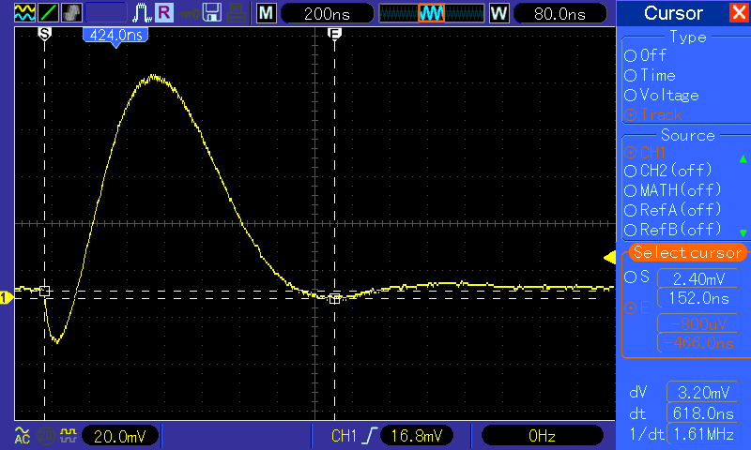

Figure 5: Second undershoot, voltage peak 3.2mV.

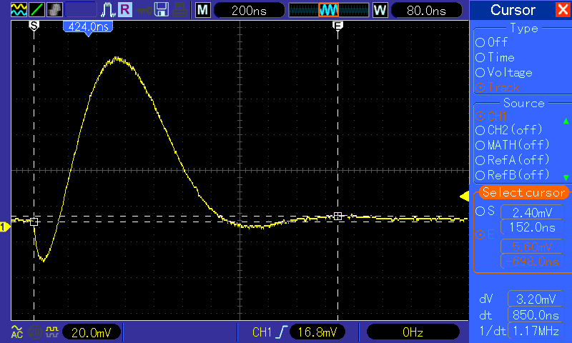

Figure 6: Second overshoot, voltage peak 3.2mV.